**Project Title :** LED sequence V1.0

**Author :** Bassel Yasser Mahmoud

**Project Description :** One button Controls 4 LEDs

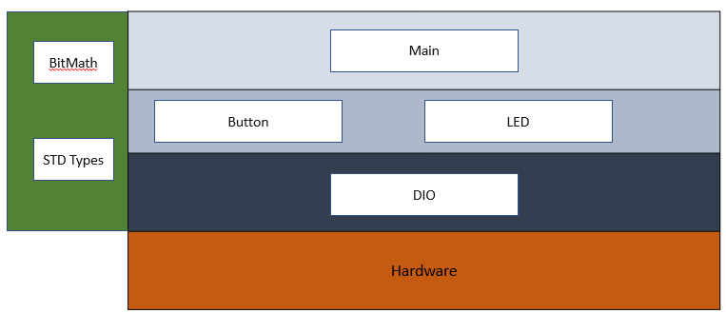**Layered Architecture:**

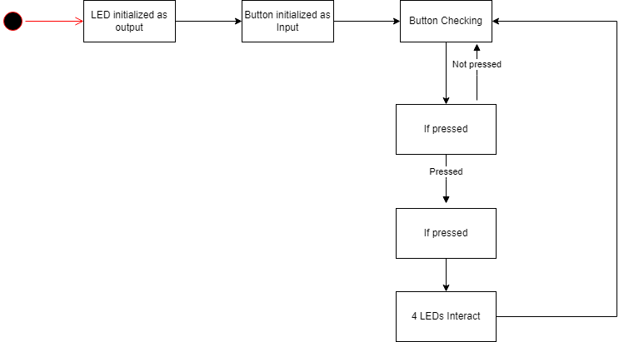**Project State machine:**

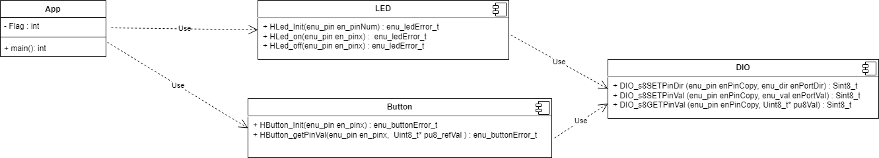**APIs State Machine:**